Sample Template for Leadership Practice Paper
Charlie E. Brown
University of Colorado Denver

Leadership Practice Paper Assignment
EDUC 7100 - Leadership in Education
Summer 2013

Abstract
An abstract left justified. Do not indent the first sentence. An abstract is a brief summary of the contents of the article that allows the readers to survey the contents of an article quickly. Like a title, it enables a person interested in the document to retrieve it from abstracting and indexing databases. The length of an abstract varies from 150 words to 250 words. It is always a good idea to check the requirements for any journal before submitting the manuscript. For this abstract, try for a length of 200 words.

[Introduction]
Take out the bracketed heading above after writing the introduction to this paper. A heading is not needed for an introduction section – it’s obvious that it is an introduction. Use this paragraph to contextualize this paper and why you are writing it and what you hope to accomplish by completing this work. Be sure to introduce the sections (headings) that will follow this brief introduction. Introductions are structural and lay out for the reader what is to follow.
Conceptual Framework Guiding this Leadership Practice Paper
The graphic presented below represents a description of the structural organization of this Leadership Practice paper (see Figure 1). If you want to use this graphic, please do so. But it was created to guide your thinking about the complexity of this paper. The lines are multidirectional in some places. You can use your own conceptual framework to match the problem of practice that you select for this paper. 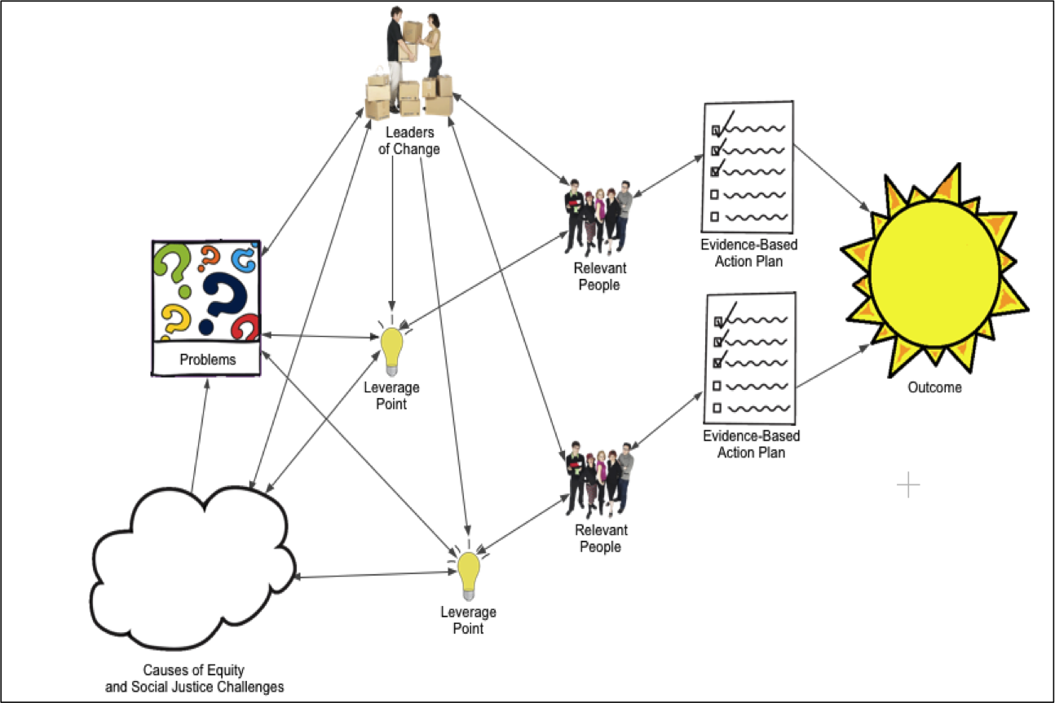
Figure 1. Graphical representation of the structural organization of this paper.

Background and Context of Leadership Practice Paper
This section begins with sharing background and context for your leadership practice paper (which includes all kinds of problems – the messy swamp and an overview of the causes of equity and social justice challenges). Once you lay that foundation, you will select one problem of practice to focus on for this paper. It should be something that you have a passion for that may end up being the focus of your thematic dissertation.
Targeted Goals (or Possible Resolutions to Problems of Practice)
Introduce this part of the paper and set up that you will be identifying a targeted goal or work focus for your leadership practice. You would talk about this goal’s importance in utility for reaching other organizational goals. Tell also that in addition to identifying a targeted goal or goals you will also be listing and briefly describing any potential outcome measures.
Description of Targeted Goals (e.g., Increasing Use of Informal Assessments)
Do your magic in this section. Describe the targeted goal or goals selected and how it or they will help you to resolve the problem of practice and why it is a worthy targeted goal. Use as many paragraphs as you need but only that many. Stay focused. Please do not use one or two sentence paragraphs. Instead us the writing conventions of M.E.A.L throughout your paper.
Potential Outcome Measures for Achieving Goal (The Sun)
Same here for this section. If your targeted goal has three potential outcome measures, use three paragraphs to describe each of these outcome measures. Identify a plan for collecting evidence that your leadership practice is impacting these outcome measures. Also name what kind of evidence you would be collecting as evidence for reaching these targeted goals.
Outcome measure one. This is an example of a level three heading. It is bolded, indented and only the first word is capitalized and is following by a period. Text follows on the same line and this section is where you would describe your first outcome measure and any data you would be collecting (see Table 1 and 2 below as examples of what you might use to present outcome measures and related data – feel free to modify these tables or create your own).

Table 1
Evidence that Shows that Targeted Goal is Being Achieved Using Outcome Measure One

Outcome measure two. This is where you would start to describe the second outcome measure and tell how these data will help with monitoring the success of your leadership practice.

Table 2
Evidence that Shows that Targeted Goal is Being Achieved Using Outcome Measure Two

After you do that you should write a short summary paragraph that tells what this first section of this paper has presented so far. Using the M.E.A.L conventions this summary paragraph should also mention that an analysis and discussion of obstacles for the implementation of this specific leadership practice will be discussed next.
Analysis of Obstacles and Implementation Plan for Leadership Practice
The first section of your paper above is really an introduction to this second section of your paper. You will need to alert the reader that this section actually has five parts and that this entire section in the document will reveal how you are going to tackle your problem of practice and that you have a plan for doing so. That action plan will include a discussion of (a) leverage points, (b) evidenced-based leadership strategies, (c) how to engage others in the leadership effort, and (d) evaluating the impact of your leadership-practice leadership effort (both content and process).
Leverage Points for Achieving Targeted Goal
Here you need to set up a short introduction to any leverage points (for your paper you will need at least two – you could have more in a real-life leadership practice). You can either use a paragraph structure to describe these leverage points, or you could use level-three headings like presented above (e.g., see Outcome measure one and Outcome measure two level-three headings above or Content and Process level-three headings below).
Evidenced-Based Leadership Strategies for Achieving Targeted Goal
Here you need to set up a short introduction to any evidence-based leadership strategies. You can either use a paragraph structure to describe these leverage points, or you could use level-three headings like presented above.
Engaging Others in the Leadership Effort
Here you need to set up a short introduction to any strategies that can be used to engage others in the leadership efforts. You can either use a paragraph structure to describe these leverage points, or you could use level-three headings like those presented above. Please call if you want to talk anything over while writing your paper (303 816-0780).
Plan for Evaluating the Impact of Leadership
Write the Introduction to this section and set up of two subheadings: (a) content, and (b) process.
Content. Text continues right after this heading and follows the double space format of previous sections. The content refers to the WHAT of your leadership effort (PD, training, additional money. Was it the right CONTENT to achieve your targeted goals.
Process. Text continues right after this heading and follows the double space format of previous sections. This section provides information about how you would go about assessing how well the PROCESS of your leadership efforts. Was the process of your leadership practice helpful in achieving your targeted goals. You do not have to have evidence for this paper, you just need to explain how you would go about assessing the process of your leadership practice.
Summary
This section should pull all the threads together into a summary statement of this paper, and end with a forward look at your next steps after writing this paper and any new learning you now have after having written this paper.

References
Sample References Below – Use or Take Out and Replace
Bryk, A. S., Sebring, P. B., Allenworth, E., Luppescu, S., & Easton, J. Q. (2010). Organizing schools for improvement: Lessons from Chicago. Chicago: University of Chicago Press.
Cashman, K. (2008). Leadership from the inside out. San Francisco, CA: Berrett-Koehler.
Calkins, A., Guenther, W., Belfiore, G., & Lash, D. (2007a). Executive summary. Boston, MA: Mass Insight Education and Research Institute. Retrieved from http://www.massinsight.org/stg/research/challenge/.
Calkins, A., Guenther, W., Belfiore, G., & Lash, D. (2007b). The turnaround challenge. Boston, MA: Mass Insight Education and Research Institute. Retrieved from http://www.massinsight.org/stg/research/challenge/.
Calkins, A., Guenther, W., Belfiore, G., & Lash, D. (2007c). The turnaround challenge: Supplement to the main report. Boston, MA: Mass Insight Education and Research Institute. Retrieved from http://www.massinsight.org/stg/research/challenge/.
Knapp, M. S., Copland, M. A., Honig, M. I., Plecki, M. L., & Portin, B. S. (2010). Learning focused leadership and leadership support. Meaning and practice in urban systems. City, WA: Center for the Study of Teaching and Policy. Retrieved from http://www.wallacefoundation.org/KnowledgeCenter/KnowledgeTopics/CurrentAreasofFocus/EducationLeadership/Pages/default.aspx.
Kutash, J., Nico, E., Gorin, E., Rahmatullah, S., & Tallant, K. (2010). The school turnaround field guide. Retreived from http://www.fsg.org/.
Seashore-Louis, K., Leithwood, K., Wahlstom, K. L., & Anderson S. E. (2010). Investigating the links to improved student learning. St. Paul, MN: The Center for Applied Research and Educational Improvement. Retrieved from http://www.wallacefoundation.org/KnowledgeCenter/KnowledgeTopics/CurrentAreasofFocus/EducationLeadership/Pages/default.aspx.
Sebring, P. B., Allensworth, E., Easton, J. Q., & Luppescu, S. (2006). The essential supports for school improvement. Chicago: Consortium on Chicago School Research at the University of Chicago. Retrieved from http://www.ccsr.uchicago.edu/content/publications.php.

Leadership  Practice  Grading  Rubric  Elements | Basic  -------- | Proficient  ---------------- |  | Exemplary  ---------------
 | 1 – 10 Points | 11 – 20 Points |  | 21 - 30 Points
Title Page, Abstract and Introduction to Leadership Practice Paper
Title Page | The title page has no running head. Page number is in wrong place.  Other errors are present on title page. |  | The title page has errors in the Running head. Running head (50 characters or less) is not in all CAPS), but other than formatting errors all elements of title page are intact. | The title page has NO ERRORS. Formatting of Running head: ACTUL RUNNING HEAD  (50 characters or less are in ALL CAPS). Double spacing is evident on the page.
Abstract | The abstract has no heading or the heading is left justified instead of centered or centered and bolded. Instead of being left justified the abstract itself is indented. |  | The abstract heading is correct. The abstract itself is left justified and not indented. The abstract is less then 200 words and captures all the main parts of this paper. | The abstract heading is non-bolded and centered. The abstract itself is left justified and not indented. The abstract is less then 200 words and captures all the main parts of this paper in a concise and interesting fashion.
Introduction | There is an introduction.  It falls short in expectations.  The [Introduction] notation is still in the paper. |  | The introduction is well written and alerts the reader to all the parts in the paper yet to come. | The introduction not only introduces the paper, its purpose, and all of its parts, but also does so in a creative and interesting way that  invites the reader into  the body of the paper.
Conceptual Framework Guiding this Leadership Practice
Description and Graphic of  Conceptual Framework  that guides the problem of practice or the organization  of this paper. | Description of the conceptual framework is basic with little evidence of how this framework will support the writing of this paper. | Description of the conceptual framework is detailed and provides evidence that s/he understands how this framework and references literature that supports this work. |  | Description of the conceptual framework is detailed, nuanced and provides for the reader evidence of not only how s/he might apply a leadership practice but also that the leadership practice has depth and is grounded in the literature on leadership for urban organizations.
Background and Context of Leadership Practice
Problem of Practice and Identification of Targeted Goal  (TG) | The Problem of Practice and the TG is unclear, not well defined, and therefore no feasible way to indicate if the goal was achieved. No references cited. | The Problem of Practice and the TG is clearly stated in positive achievable language that would indicate if the goal was achieved. Some references cited. |  | Not only is the TG clearly stated in positive achievable language that would indicate if the goal had been achieved, but also the goal is well grounded in the literature for leadership for urban education.
Potential  Outcome  Measures  (OM) | Little is provided  in the way  of a potential OM. No references cited. | One or more potential OM related to the TG is presented. Some references cited. |  | Several OM that are linked to the TG along with strong support from the literature on the literature for urban organizations are presented.
Outcome Measures  Evidence Tables | There is no OM table indicating type of data to be gathered or presented. | An outcome measure table is provided, and sample data or types of data to be gathered or presented. |  | An outcome measure table is provided, and sample data to be gathered or presented. The table is easily understood and presents sample evidence for reaching goals.
Analysis of Obstacles and Implementation Plan for Leadership Practice
Introduction | There is a basic introduction to this section of the paper but key parts are missing. | The introduction to this section sets up all the parts of this section to follow. |  | The introduction to this section sets up all the parts to follow in a way that encourages the reader to continue reading this paper.
Leverage Points  (LP) | At least one LP was presented but without a rationale for selection or how the LP when engaged would counter obstacles or achieve the targeted goal. No citations. | Several LPs were presented along with a rationale for selection and how when engaged they would be capable of countering obstacles and achieving the targeted goal. Some citations were offered. |  | Several LPs related to the targeted goal along with a rationale for that selection that are well supported with references to the literature on leadership for urban organizations. This section is written is such a way that the reader can follow the logic of how action on and from these leverage points has the potential to counter and overcome obstacles and lead to the achievement of the targeted goal.
Evidence-Based Leadership Strategies  (E-BLS) | At least one E-BLS is presented, but no rationale for the selection of, or how E-BLS strategy intersects with overcoming obstacles or engaging LPs in order to achieve the goal. No references. | Several E-BLS are presented with rationale for selection, but response does not provide an argument for why that strategy could influence LP or the behavior of others. Some references are provided. |  | A combination of E-BLS linked to LPs that purport to overcome obstacles and to make gains on achieving the targeted goal are presented along with a compelling rationale. The argument for this combination of E-BLS is well grounded in references from the literature on leadership for urban organizations.
Engaging Others  in the  Leadership Effort  (EO) | The rationale for EO is provided. No “OTHERS” are identified. No references are cited. No HOW TO activities are offered. | The rationale for EO is presented (others are identified), along with references from the literature on leadership for urban education. One or more HOW TO strategies for EO are offered. |  | Author links the rational for EO (with others identified) to leadership efforts to engage LPs with specific E-BLS efforts in order to overcome obstacles and to achieve goals. HOW TO strategies suggested are grounded not only in the literature on leadership for urban organizations but also in the literature on collaboration.
Evaluating  the Impact of  Leadership  (Theory of Change)  Content | Evaluation plan is not well specified and does not reference any measures to the “theory of change” of the leadership effort (Content). | The evaluation plan specified takes into account the TG, OM, LP, E-BLS, EO related to this project (as related to the “theory of change” of the leadership effort (Content). |  | The evaluation plan specified takes into account the TG, OM, LP, E-BLS, EO related to this project (as related to the “theory of change” of the leadership effort (Content) of the leadership effort. This plan is well grounded in the literature of leadership for urban organizations.
Evaluating  the Impact of  Leadership  (Theory of Implementation)  Process | Evaluation plan is not well specified and does not reference any measures related to the “theory of implementation” (Process) of the leadership effort. | The evaluation plan specified takes into account the TG, OM, LP, E-BLS, EO elements as related to the “theory of implementation” (Process) of the leadership effort. |  | The evaluation plan specified takes into account the TG, OM, LP, E-BLS, EO elements as related to the “theory of implementation” (Process) of the leadership effort. This plan and its elements are well grounded in the literature of leadership for urban organizations.
Summary
Now that I’ve  written this paper, what am I thinking  now and what new learning do I have about leadership  and making change regarding problems  of practice in organizations. | The summary pulls together most of the threads in the paper. There is no reference to new learning. |  | The summary pulls together the threads of paper and provides any possible new perspectives on the problem of practice. Some citations to references were made. | The summary pulls together the threads of the paper, provides a new/alternative perspective on the problem of practice, and outlines several next steps for taking on this problem in real life or possible thematic dissertation topic. This summary makes references appropriate literature on leadership for urban organizations.
APA Formatting and M. E. A. L. Writing Conventions
Title Page, Headers,  Running head,  Page Numbers,  Title, Author(s),  Institutional Affiliation, Abstract, Headings,  Levels of Headings,  Indented Paragraphs,  Correct use of Series, Correct use of Lists,  Block Quotes, Citations in Text, References | Many APA formatting errors. No evidence of awareness of APA style. |  | Only a few APA formatting errors. | APA formatting in this paper is  Sheer Perfection! Absolutely no errors.
M. E. A. L.  Writing Conventions | No evidence of having ever read about M.E.A. L. writing conventions. |  | For the most part this Leadership Practices paper utilizes well the M.E.A.L. writing conventions. | Well written, because the M.E.A.L. writing conventions are deeply embedded in the writing of this paper.
16 sections for 450 Total Possible Points (with a 30 point buffer).
(? X 10 or less) + (? x 19 or less) + (? x 30 or less) = ??? – ERRORS = Final Score (up to 450)

